**MOSTAFA IBRAHIM**

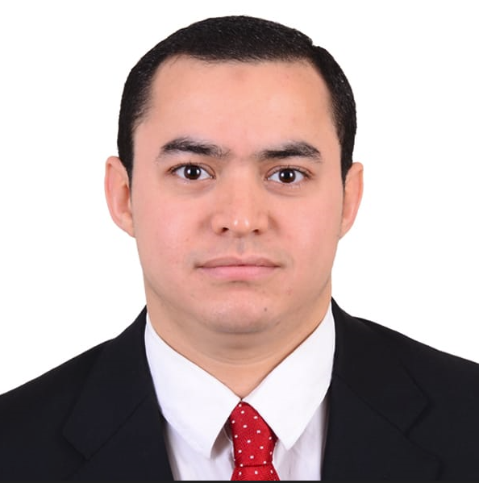

Senior Reservoir Engineer

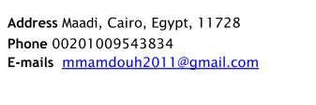

**LinkedIn** linkedin.com/in/mostafa-Ibrahim [125ba851](https://www.linkedin.com/in/mostafa-ibrahim-125ba851?lipi=urn%3Ali%3Apage%3Ad_flagship3_profile_view_base_contact_details%3BonRt5xS7QtCCjrn87xoJog%3D%3D)

# Education

* **Master of Science** in petroleum engineering; Cairo university in Egypt, faculty of engineering in 2017
* **Bachelor’s** degree in petroleum engineering; Suez Canal University in Egypt in 2010 with honor degree.
* **Diploma** in Base Business Simulation, Celemi Decision “strategic, business and financial fundamentals”
* **MBA**, ESLSCA Business School, In Progress (Cumulative Grade A, GPA 4.0)

# Trainer Experience

**-Main Delivered Courses** ( Attendees same company)

* INTERSECT Reservoir Simulation (introduced to **ADNOC**, UAE)
* Integrated Production Modeling prosper, GAP, MBAL, PVTP (introduced to **KPO**, Kazakhstan)
* Electric Wireline Technology Production Logging (introduced to **KPO**, Kazakhstan)

**-Main Delivered Courses** ( Attendees Different Companies)

* PVT, Phase Behavior of Reservoir Fluids and EOR
* Reservoir Management and Monitoring
* Reservoir Simulation (black oil)
* Advanced Well Test Design and Analysis
* Advanced Reservoir Engineering
* Advanced Water flooding Gas injection WAG (Enhanced Oil Recovery)
* Petrel for Reservoir Engineers
* MBAL
* Reserve Evaluation
* A Critical Guide to Reservoir Appraisal and Development.
* Basic RE for Non-PE background

|  |  |  |
| --- | --- | --- |
| **Career History** |  | |
| Senior Reservoir Engineer | GUPCO/Dragon Oil JV, Cairo, Maadi | 2019-09 – Current |
| Senior Reservoir Engineer | BP Egypt Secondee in GUPCO, Maadi | 2018-03 - 2019-09 |
| Reservoir Engineer | GUPCO/BP JV, Cairo, Maadi | 2012-10 - 2018-03 |
| Reservoir Engineer | PetroGulfMisr /PICO JV, Cairo, Maadi | 2011-12 - 2012-10 |
| Petroleum Engineer | PetroGulfMisr /PICO JV, GOS | 2011-05 - 2011-12 |

# Experience and Accomplishments:

13 years of working experience in **Reservoir Engineering** with the following achievements:

* Reservoir Engineering's Ideal Employee for 2017 (GUPCO-BP JV)
* I finished my Master of Science thesis in reservoir engineering, which included reservoir modeling for multilayered heterogeneous reservoirs. Using Nexus reservoir modeling software, the primary uncertainties and optimal procedure have been highlighted, particularly when the STOIIP is uncertain.
* Plan, manage and coordinate all field development operations and plans for 16 oil reservoirs and 4 gas reservoirs.
* Lead a thorough conformance review study for the Morgan field at GOS, including various well-work and workover suggestions with a gain of 7400 BOPD.
* Completed field development plan for Nezzazat reservoirs in GOS using 3D reservoir simulation using Nexus and PETREL/Eclipse, which showed high potential of drilling 6 wells and optimizing their locations, which increased ultimate recovery factor by 20% utilizing low-value SI wells to be drilled deep side-track and reduce drilling cost by 50%. These campaigns increased the production rate by 5000 BOPD.

**-** Completed field development plan for Nubia reservoirs, incorporating rock type and historical production and saturation data to identify potential unswept oil zones and offer the best well-work approach to develop these zones with 3500 BOPD gain.

* Lead a comprehensive regional study to assess the impact of sister company production on one of our concessions in the lower Rudies reservoir in order to evaluate and reactivate long-term shut-in wells on our land with 2000 BOPD.
* Lead a comprehensive integrated development plan for the Baba reservoir, including geological and technical disciplines, to begin development in three wells with a 3000 BOPD gain.
* I participated in various reservoir modeling studies that used Nexus/ VIP or ECLIPSE to develop field depletion plans and prioritize new well deliveries at rig timetable.
* Performed a Water-flooding optimization study (area average daily production of 14,000 BO and maximum daily water injection capacity of 250,000 BW with 170 active wells) to set target reservoir pressure and VRR and the additionally added reserve under WI
* Completed a study on the lower Rudies reservoir to better understand the main drive mechanism and to determine the value of beginning WI via a new route in the field to optimize oil recovery.
* Completed a study on the Nubia reservoir with a gas cap and a modest oil rim to determine the best timing to begin gas cap blowdown in order to generate 60 BCF of gas reserves using current well stock.
* Completed study on the Kareem reservoir, which produces under waterflood with the original gas cap. The study emphasized the benefits of water flooding as well as the long-term detrimental impact of producing gas from the gas cap to SI gas cap producers and delaying gas cap blowdown till 2029.

# Key Accountabilities

I work as a senior reservoir engineer in a multi-disciplinary team at GUPCO. The team's mission was to run and design a development plan for numerous reservoirs at various phases of development, from

appraisal to maturity, with a total of 400 wells and an estimated OIIP of 4 billion barrels.. During that time, my primary responsibilities are to

* Plan, monitor, and coordinate all reservoir engineering work in the South-Central Gulf of the Suez region, which accounts for 50% of GUPCO's overall output.
* Create a re-activation strategy for dormant wells with a variety of issues.
* Reservoir simulations with Nexus or Petrel/Eclipse simulators. Qualified to create a comprehensive model with all input decks and execute all modeling phases from model inputs QA/QC, initialization, history matching, and forecasting. Ensure that new wells drilling adds additional reserves based on the optimal number, location, and trajectories.
* Risk and uncertainty analysis, providing hydrocarbon profiles for project commercial evaluation.
* Provide subsurface evaluation through detailed reports to support asset teams in identifying new well delivery opportunities including reserves, bottom-hole location, surface considerations, risk assessment, contingency plans, economics, approval, execution, and follow-up drilling and completion operations. work programs.
* Design and perform pressure transient analysis Manage mature fields with high water production. Support the appraisal activities for south central GOS.
* Train and develop other junior reservoir engineers on relevant skills to enable them to become proficient on the job.
* Reserve booking in accordance with PRMS guidelines.
* Design and monitor new well delivery plans, which include well production, RFT, fluid sampling, and logging.
* Preparing fluid sampling plans (subsurface and surface recombination samples) for PVT analysis, as well as being in charge of lab experiment planning and follow-up.
* Aid in the maintenance of a portfolio of undeveloped fields/reservoirs ready for exploitation in order to respond swiftly to rig scheduling demands to construct extra production capacity and/or prolong the present production plateau.
* Work with project and engineering teams to rank and prioritize the construction of new surface facilities or de-bottleneck the current ones.
* Worked on the design and supervision of work-over plans that included additional perforations, water shut-off, and re-perforation.
* Ensures technical consistency among reservoir engineers, petroleum engineers, drilling engineers, geologists, geoscientists, petrophysicists, and paleontologists in order to offer valuable business cases in terms of reserve and cost.
* Planning and tracking annual reservoir surveillance plans and recommending necessary actions.
* Designing and supervising well-work plans including additional perforations, water shut-off, and re-perforation.
* Assist in general assembly meetings for allocating Budget concerning new pipeline installations, new well delivery, and well-work plan.
* Set up fixed schedule meetings with all engineering teams "reservoir, petroleum, production technologist" one hour weekly to discuss weekly operations and lessons learned and how to enhance performance.
* Set up bi-weekly meetings with all reservoir engineers and geologists to review new well delivery options. Work with portfolio management to evaluate and prioritize underdeveloped fields.
* Annually evaluate volumetric calculations and R.F for important producing reservoirs with geologists and petrophysicists.
* EOR projects screening and evaluation.
  + Bright water project evaluation.
  + Evaluation of the LoSal Project application for all reservoirs in the GOS central area.
* Create scenarios for "production commingling visibility" by choosing suitable wells to perforate underdeveloped behind-the-pipe reserves: early revenue with less investment and no subsurface or surface flow issues.
* Build production forecast scenarios considering analytical techniques such as Decline Curve Analysis (DCA) to judge the development plans and the estimated ultimate reserves.

# Publications

* Author for SPE Paper entitled "Rejuvenation of a Mature Field through STOIIP Validation with an integrated 3D Geo-Cellar Model and 3D Dynamic Model for a Heterogeneous Multi-Layered Reservoir" paper number: SPE-183565-MS. Presented at the ADIPEC conference Abu-Dhabi 7–10 Nov 2016.
* Co-Author for SPE Paper entitled A Road Map for Integrating a Giant Field: Case Study; paper number: SPE-164717.
* Co-Author for SPE Paper entitled An Integrated Approach For Reservoir Modelling Of Complex Miocene Fan Delta Sandstone El Morgan Giant Field A Case Study From Gulf Of Suez, Geo Tech Gas & oil technology showcase and conference.

# Training

* English (**TOEFL ITP**, Score **587** out of 677)
* Petroleum Economics and agreements
* Formation Damage
* Practical reservoir simulation workshop on Nexus/VIP software
* Prospect evaluation and risks.
* Gas lift optimization
* Advanced well testing
* Applied reservoir engineering
* Practical Waterflooding
* Advanced PVT
* Practical reservoir simulation workshop on PETREL/ECLIPSE software

# References

* Eng. Nasr Ramadan | Ops. GM. | PICO Egypt | Ex. ADNOC Group | +201021277498
* Eng. Yasser El-Masri | Ops. GM. | SDX Egypt | Ex. ADNOC Group | +201021277498
* Eng. Hisham Mousa | Engineering GM. | Dragon oil Egypt | Ex. ADNOC Group

[| heslim@dragonoil.com](mailto:heslim@dragonoil.com) | +201068164327

* Geo. Mahmoud Gabr | Resource Progression Team Leader | BP Egypt

[| mahmoud.hassaan@uk.bp.com|](mailto:mahmoud.hassaan@uk.bp.com) +201093717494

* Eng. Mohamed Adly | Senior Reservoir Engineer | BP Egypt

[| mahmoud.hassaan@uk.bp.com](mailto:mahmoud.hassaan@uk.bp.com) | +201001225682

* Geo. Mohammed Talaat | Resource Progression Team Leader | Dragon oil Egypt

[| mgafaar@dragonoil.com](mailto:mgafaar@dragonoil.com) | +201003640240

# Personal Bio

Date of birth: November 23, 1987

Nationality: Egyptian

Marital Status: Married